**Audience Notes:**

* Working MPP project
* Next V1 scope
* Dashboard – Loyalty information, account information,
* NCS and MPP integration – Technical constrains
* Link to I-service, NCS
* I-Service web site – API integration
* Two separates account NCS and MPP (subscription)
  + Information from NCS – basic information is pulled out (First Name, Last Name, email, address and Credit card to validate data integration)
* MPP – Stubbed out the Epic and Use cases – will be stubbing out the user stories
* Leanne to invite Wipro team for the user story planning meeting
* Apps are not of V1 release
* Push notification and SMS rollout – after Aug release
* Experian release before from MPP
* Dynamic pricing model as part of the release
* MPP provides plugin for Akamai and any clarification will be used via Jira (MPP system)
* Print subscription thought NCS only
* Market by Market transition (based on region) – product management group will take a decision on the rollout
* MPP is set-up on regional product wise
* Experian - Using email and new letters – several new letters are shared with customer (exact target) – breaking news
* Corn job enabled to send email, email via link sent to customer (breaking news)
* Email subscription are categorized like breaking news, sports etc.
* Automatic data movement to Experian – no there are some technical challenge which are been discussed with vendor
* Import data from different target and handover the file to system – working in progress, data structure discussion going on
* Anonymous users can get the new letter including subscribed users also.
* Experian enabled the API to interact with system to fetch data
* S-FTP (secured File transfer protocol) are used for file transfer
* Form post will be used
* Automation content or Manual content change will happened based on breaking news
* SMS –Global Mobile vendor for push
* Deal and coupon – deal saver
* Experian has report captured on email, or any other action information traced by a metrics
* Future roadmap will be MPP and Experian
* Enterprise market Parent - each market will be a child template

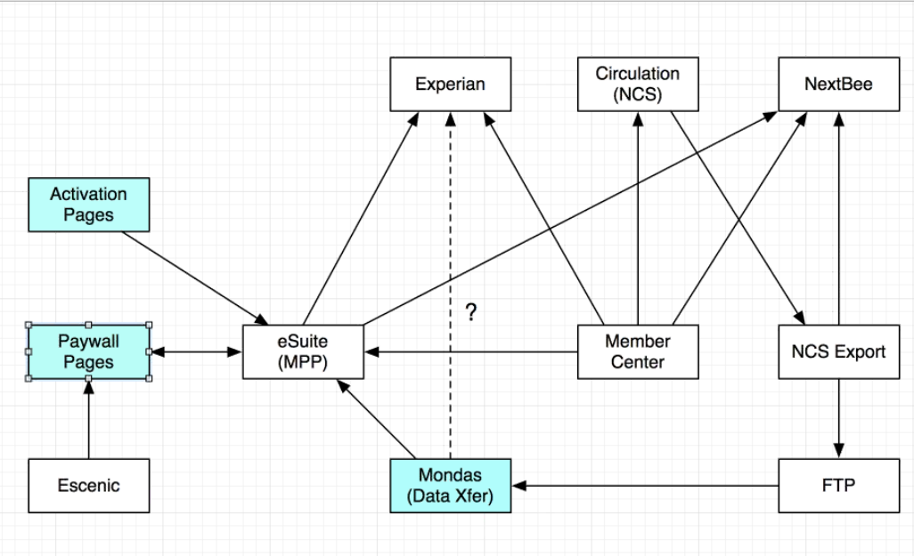

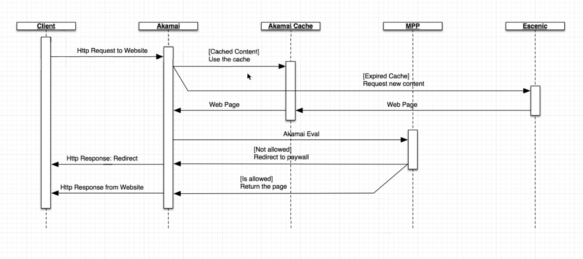

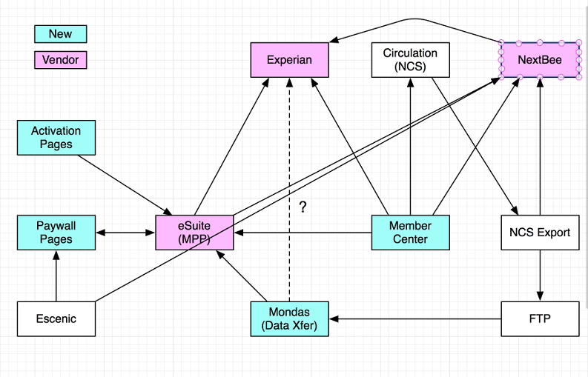

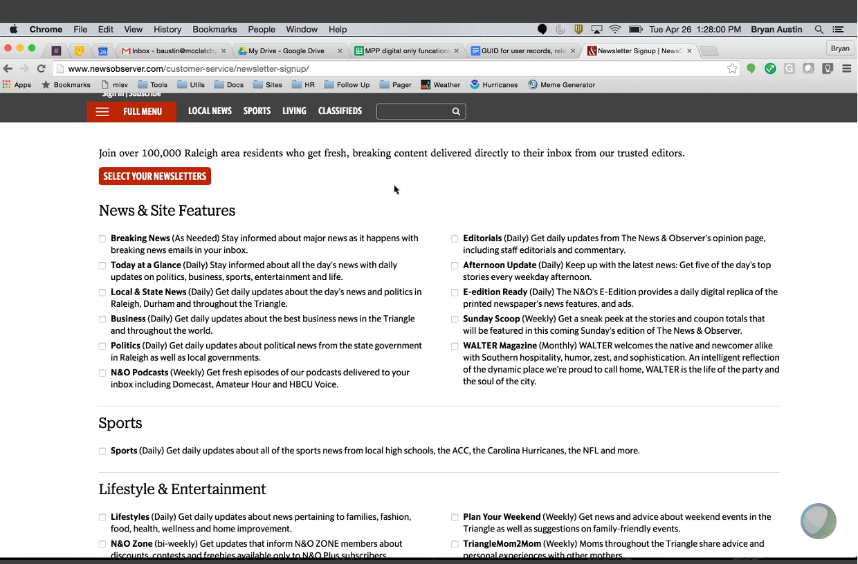

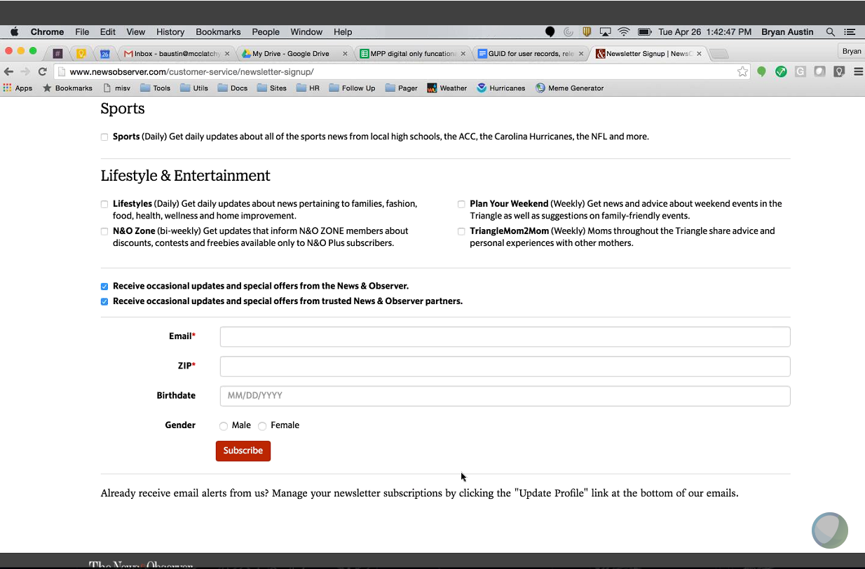

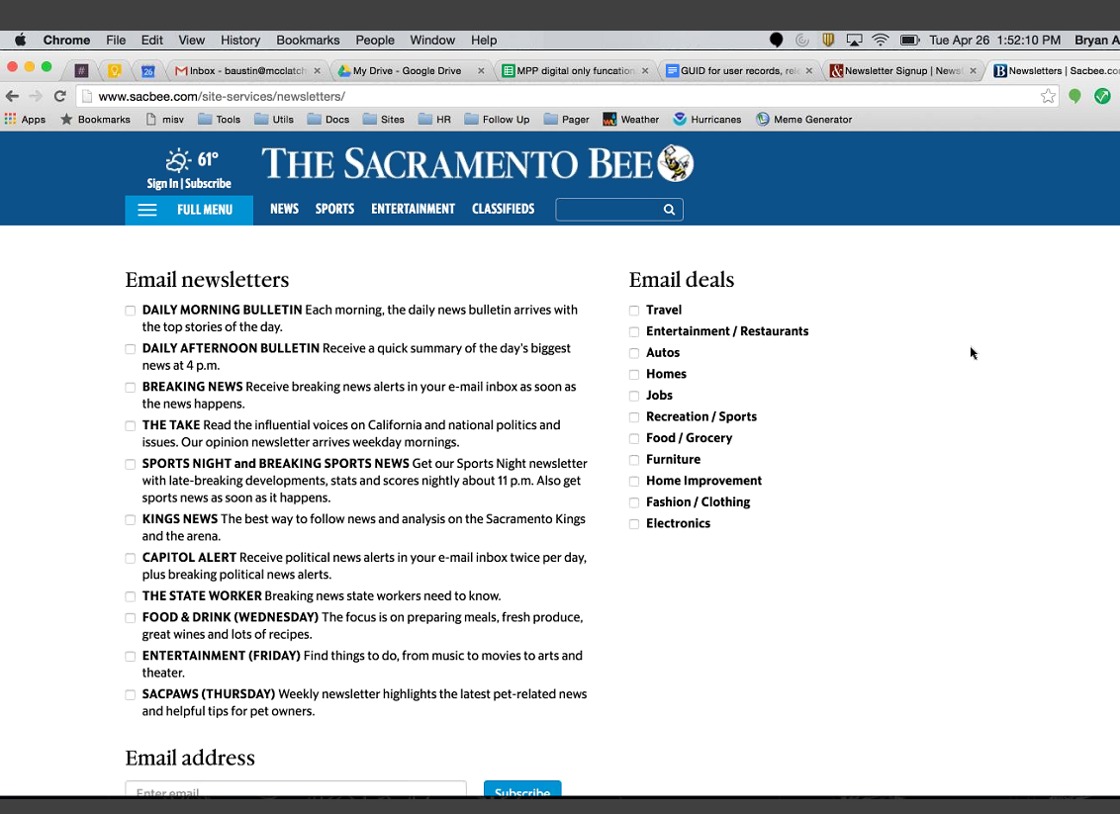

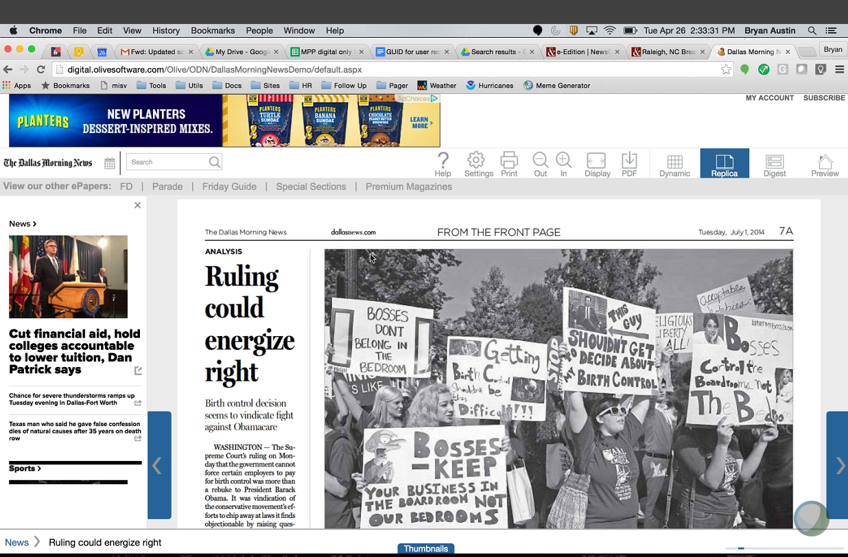

Olive:

* News gate to Olive – push gate
* Email goes without notification – E-Edition
* E-edition apps to stores
* Schedule job to send out notification
* Changes to Olive will interface with MPP